Walkthrough 7 JSON Model

https://sapui5.hana.ondemand.com/#/topic/70ef981d350a495b940640801701c409

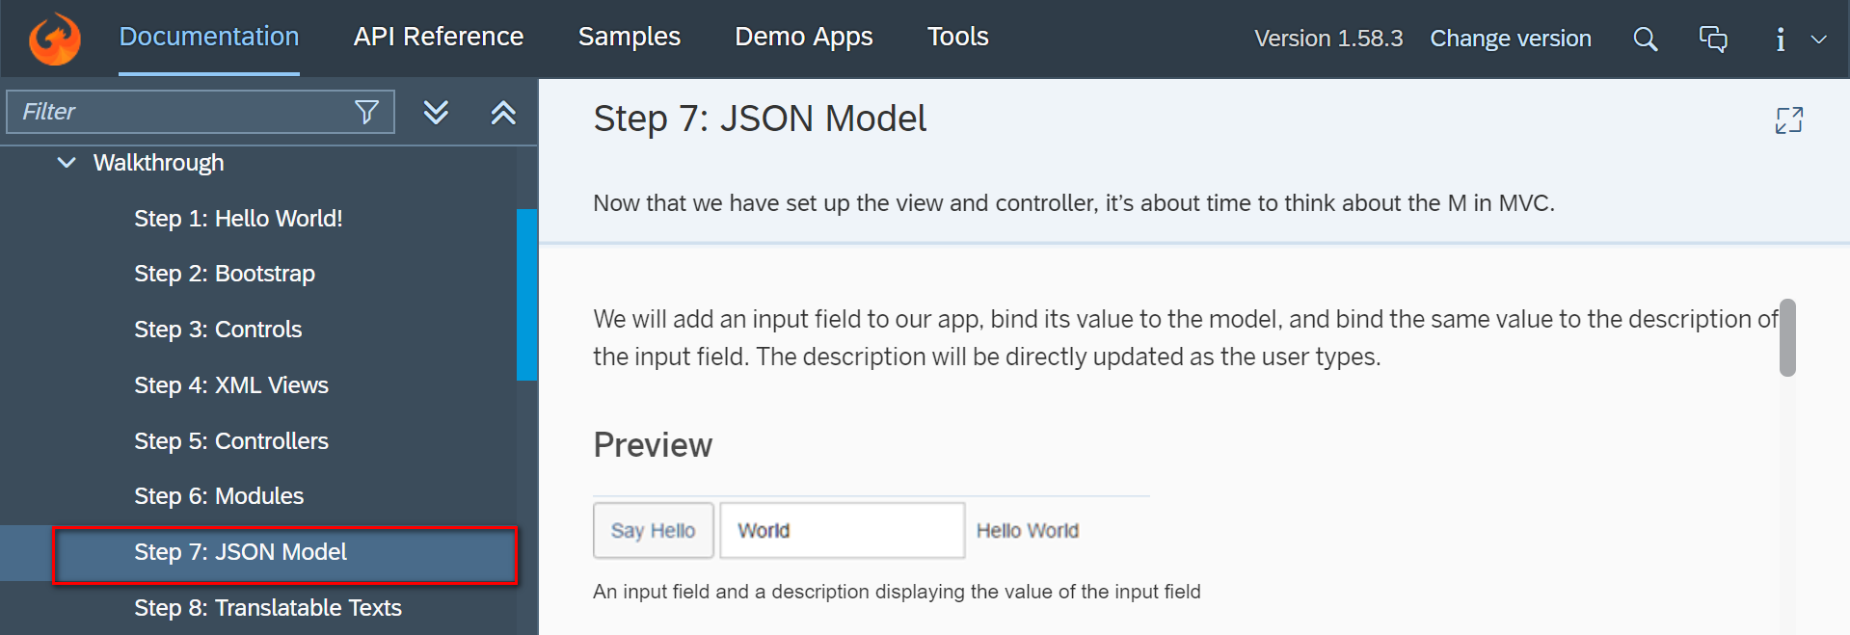

Core Codes:

Controller.

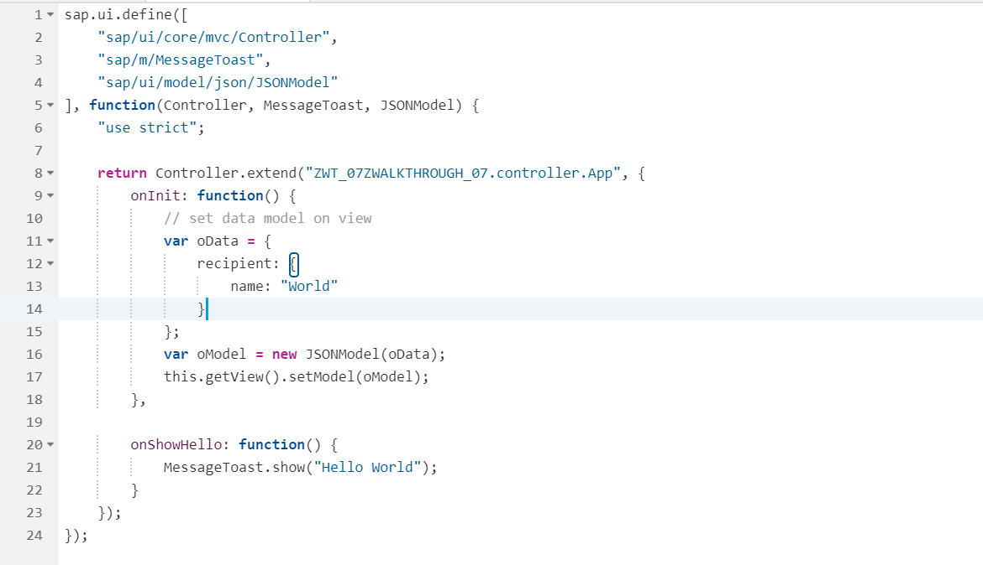

View.

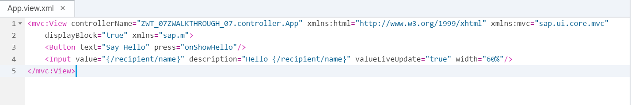

Git:

Result:

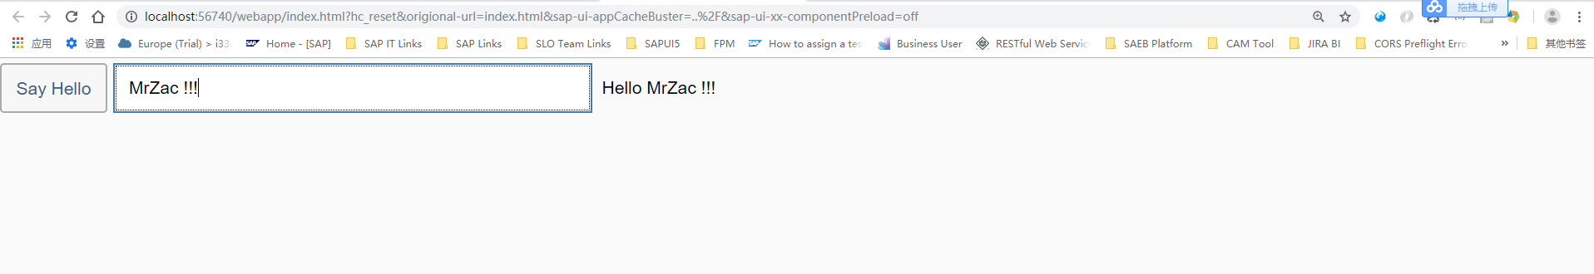

2018/11/02 XiaoMi Beijing Zac,Xie